Canine Feeding Guidelines
Feeding can vary from brand/type as well as based on the dog’s needs. Use these charts as a general guideline and adjust based on your individual dog. Adult dogs should be fed twice per day and puppies 8 weeks and over should be fed 3 to 4 times per day.
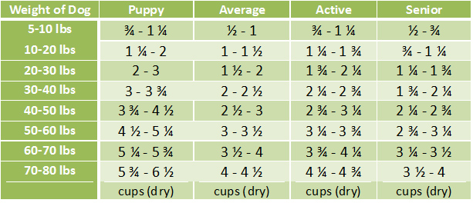
*The above chart is how much dry food to feed per day. Please include at least ¼ can of wet food per day as well. You can mix this into their dry food.

Additional note: If you are unsure how much to feed your puppy, set down what you think is an appropriate amount. If after 10 minutes, there is still food leftover, pick up the dish and feed slightly less at the next meal. If the puppy appears ravenous, you may need additional feedings during the day. If this is the case, you’ll want to feed out of a puzzle or slow feeder to assure the puppy does not eat too rapidly. We can provide one of those if needed.

