ARLGP Volunteer Hoodies are available at a discounted rate!
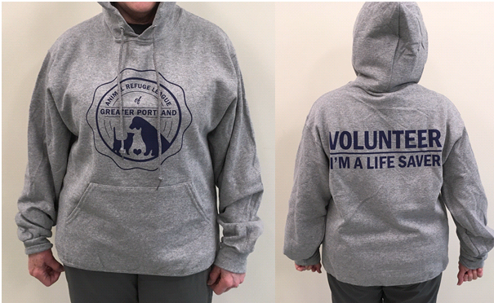
$25.00

Sweatshirts are gray with blue lettering as shown.
To place your order, just go to: www.arlgp.org/volunteersweats

